# P234.2

#include<iostream>

using namespace std;

class student

{

public:

char name[20];

unsigned int id;

double score;

void input();

void output();

};

void student::input()

{

cout<<"name?";

cin>>name;

cout<<"id?";

cin>>id;

cout<<"score?";

cin>>score;

}

void student::output()

{

cout<<"name:"<<name<<"\tid:"<<id<<"\tscore:"<<score<<endl;

}

int main()

{ student s=student{"\0",0,0};

s.input();

s.output();

}

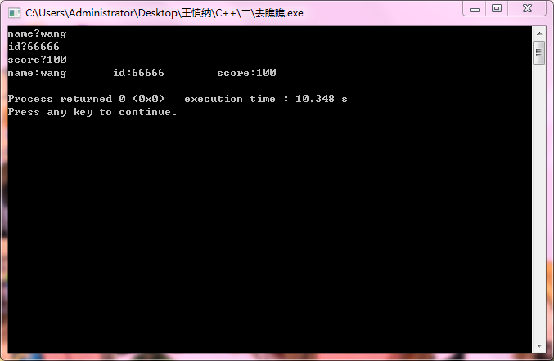

**P242.1**

#include<iostream>

#include<cstring>

using namespace std;

class Book

{

public:

double price;

int number;

char bookname[30]="黑雪公主和七个小高人";

void display();

void borrow();

void restore();

};

void Book::display()

{

cout<<"这本书的名字是："<<bookname<<endl;

cout<<"这本书的价格是："<<price<<endl;

cout<<"这本书的总共有："<<number<<endl;

}

void Book::borrow()

{int a;

cout<<"请输入要借阅的书的名字："<<endl;

cin>>bookname;

cout<<"请输入要借阅的数量："<<endl;

cin>>a;

if(number==0)

{

cout<<"该书已被借阅完毕，请见谅";

}

{

number-=a;

}

cout<<"恭喜您，借书成功！"<<"\n这本书还剩："<<number;

}

void Book::restore()

{int b;

cout<<"请输入要归还的书名："<<endl;

cin>>bookname;

cout<<"请输入要归还的数量："<<endl;

cin>>b;

number+=b;

cout<<"恭喜您，还书成功！"<<"\n这本书目前剩余量："<<number<<endl;

}

int main()

{

Book Book1;

int i;

Book1.price=22.5;

Book1.number=50;

cout<<"欢迎来到暗黑童话小书屋"<<endl;

while(1)

{

cout<<"查阅书籍请按1，借书请按2，还书请按3"<<endl;

cin>>i;

switch(i)

{case 1:Book1.display();break;

case 2:Book1.borrow();break;

case 3:Book1.restore();

default:cout<<"大侠，输错数字了哦，请重头来过";}}

return 0;

}

# C:\Users\Administrator\Desktop\王慎纳\C++\五\作业二.png

# P242.4

#include<iostream>

using namespace std;

class student

{

public:

double score;

static double total;

static int count;

void scoretotalcount(double);

static double sum();

static double average();

};

double student::total=0;

int student::count=0;

void student::scoretotalcount(double s)

{

score=s;

total+=s;

}

double student::sum()

{

return total;

}

double student::average()

{

return total/(double)count;

}

int main()

{

student w;

int i;

int count;

double s;

cout<<"请输入班级学生总人数："<<endl;

cin>>count;

student::count=count;

for(i=1;i<=count;i++)

{cout<<"请输入第"<<i<<"个学生成绩";

cin>>s;

w.scoretotalcount(s);}

w.sum();

w.average();

cout<<"本班同学总成绩为："<<student::sum()<<endl;

cout<<"本班同学平均成绩为："<<student::average()<<endl;

return 0;

}

